Introduction

As the development of portable devices(smartphones), mobile games development industry is growing very fast, according to the research by the developer Dot Com Infoway, in 2021, mobile gaming is expected to dominate the market with 59 percent gaming market shares.[1] Smartphone allows user to play games at anywhere and anytime, and especially with the 3-dimensional games due to its rich perspective, shadow and special effects as nowadays smartphones tend to have more powerful system that can handles 3d games smoothly and bring user more luxury gaming experience. Android phone as one of the smartphones have large number of users of the market. Since why Android Game account for a considerable proportion of the mobile game development industry.

The intent of this project is to design and develop a 3-dimensional game that is playable on an Android mobile device. There are many game engines or platform exist for android game development. Unity is one of the most commonly used engines amongst developers. It had very powerful visual editor to make the development much easier. Unity also provide an excellent implementation of entity or component model that solve programming problem much simpler. Unity is easy to learn which means it is also suitable for beginner.[3] Android Studio is the official integrated development environment for Android application development. It has an interface called IntelliJ iDEA which provide an intelligent code editor that makes code more accurate.[4] The game will be developed using the Android Studio, because Android Studio is a great way to learn the game specific features whereas Unity, I won’t be learning much about creating games as learning about how to use Unity.

Opengl Es is a software interface used to render 2d and 3d graphics. It is used on embedded and mobile systems.[2] Opengl Es is similar to Opengl learned on AC41001. To be more specific it is a subset of OpenGL, it has less functionality compare to OpenGL.

Prototyping:

Several Prototypes were created before making the actual game in order to learn the opengl ES and Android Studio.

The first prototype was to setup the openglEs on Android Studio using the tutorial found on this website [5].

The second Prototype was simple introduction to openglEs on Android Studio. It was basic 2d triangle that was created and display on screen. Then based on the triangle create a 3d cube.
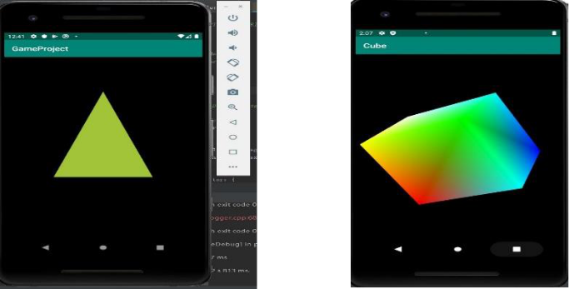

The third prototype was based on the cube from previous prototype, it has the images(textures) been added to each face of the cube, I also make the cube has the function to rotate.
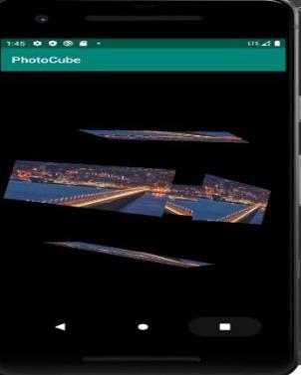

Game Concept
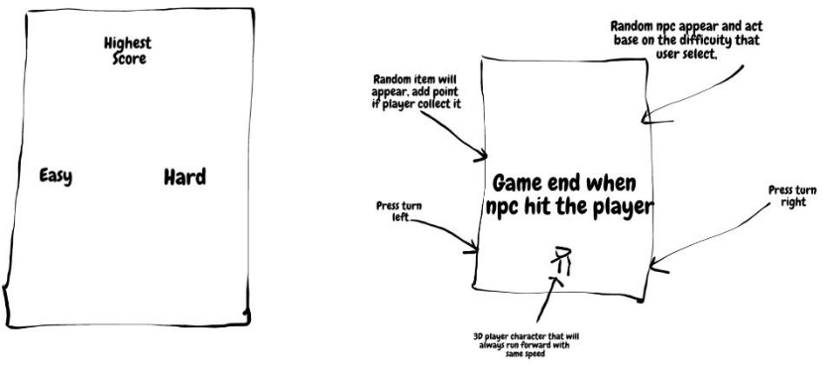

Target Audience

This project is to create an Android game so the game will run on an android device. The player can pick up and play the game whenever they like- be at home or on the go. There is not restriction on age and gender at all for the game. Therefore, the target audience can be anyone that have an android mobile device to install and play the game.

Methodology

An agile software development approach was adopted for this project. A regular, weekly meetings were held with the supervisor throughout the project. The project will be separate into different section and to be complete within the time base on the design plan.

- https://www.digitalinformationworld.com/2019/08/infographic-mobile-game-market-trends-2020.html - Dot Com Infoway

- https://www.khronos.org/opengles/

- https://www.redappletech.com/how-good-is-unity-for-game-development/

[4]http://androiddeveloper.galileo.edu/2017/03/29/android-studio-and-android-sdk-tools/

- https://developer.android.com/training/graphics/opengl/environment?hl=en

